Q1



The output and predicted class of the first instance in the dataset using the provided weights are Chinstrap and 1 respectively.

Q2

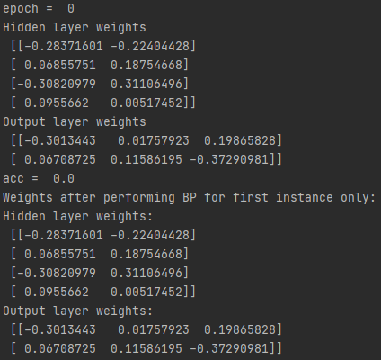

**Q3**

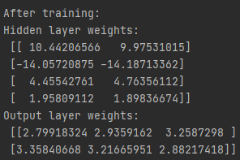



The accuracy is around 38%. I think more epochs will help improve that.

Q4

My network performed worse compares to what I expected. After trained 100 epoch the accuracy is below 40%. It is not overfitted because the performance on train set and test set are alike.